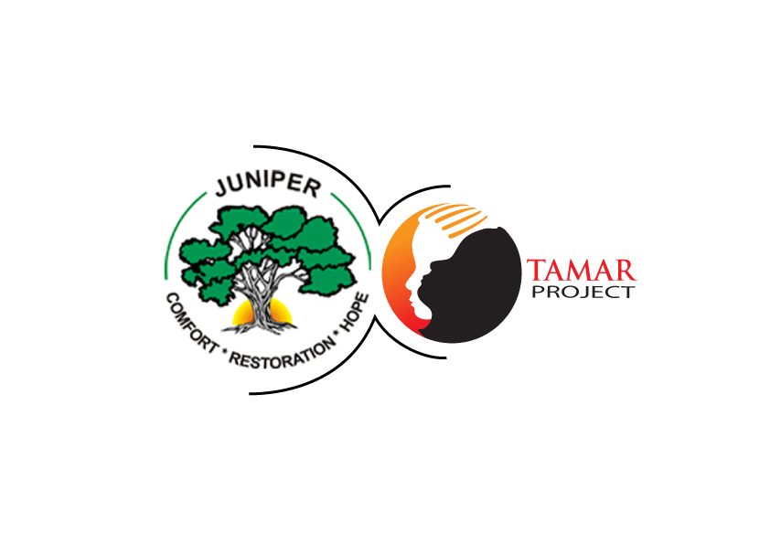

THE TAMAR PROJECT LAUNCH

DATE: NOVEMBER 21st. 2014

VENUE: ANGLICAN JUNIOR HIGH SCHOOL, FUMESUA

THEME: SEXUAL ABUSE: PREVENT IT! REPORT IT!

BACKGROUND:
Sexual abuse of children is a topical issue in Ghana today. There is no week that our media do not report on one case or another. In spite of all that Ghana is doing to curb this; it is disturbing to know that child sexual abuse is on the increase.
Regional News of Saturday, 4 October 2014 downloaded from the Ghana web indicates that
"About 33% of children in Ghana are said to have been sexually abused. The abuse includes rape, molestation, touching of private parts, watching pornography, the use of inappropriate language, and dirty jokes.
Again, according to the news of January 10th 2014 downloaded from the Ghana web, ASP Irene Oppong, the (PRO) of the Domestic Violence and Victims Support Unit (DOVVSU) of the Ghana Police Service reported that child sexual abuse is on the increase.
According to her, statistics available to the unit indicate a sharp rise in reported cases for 2013.
“Comparing last year, the first quarter to the third, to the previous years, it shows that there is an increase in defilement cases and the Greater Accra region top the list. About 95% of the perpetrators are known to the victims meaning that there is some sort of relation.”
August 6, edition of the Daily Graphic which reads "Man, 44 defiles daughter at gun point".

Our boys are not exempted from this either. Again Ghana web General news of October 24 reports the case of a 16 year old that was sodomised by a Doctor.

The situation is alarming taking into account the fact that many of these abuses go unreported because of the stigma and cultural constraints.

Children who have been abused are more likely to suffer from psychiatric problems, be promiscuous, and suffer from many other ailments that require medical care. Furthermore, victims of sexual abuse are normally full of anger and rage; they become bullies in our schools, and deviants in the society.

The cost to the nation in terms of health care, justice system, and loss of human resources can be anyone’s guess. It is therefore crucial not only to highlight the effects of sexual abuse on the individual and the society but more importantly to emphasise the need for prevention.

Juniper Tree, a Christian Non-Governmental Organization (NGO) is therefore launching a ten year nationwide campaign dubbed the "Tamar Project" in collaboration with other stakeholders: The Ministry of Education and the Social Welfare Department to drastically reduce the incident of sexual abuse if not completely eradicate it in the next ten years through education.

